**Experiment No. 1.2**

**Student Name: Rishav Kumar UID: 22MCC20039**

**Branch: MCA - CCD Section/Group: MCD-1/ Grp A**

**Semester: IV Date of Performance: 25th Jan 24**

**Subject Name: Big Data Analytics Subject Code: 22CAP-782**

1. **Aim/Overview of the practical:**

File management tasks in Hadoop

1. **Code for practical:**

* Open terminal in Ubuntu and use following command to switch user:

***sudo su - hadoop***

* Start servers using command:

***start-dfs.sh***

***start-yarn.sh***

OR

***start-all.sh***

* After starting namenodes and datanodes, make a local folder named localData.

***mkdir localdata***

* Then create to create a file in Hadoop using fs use command:

***hadoop fs -mkdir /22mcc20039***

* To view all directories in Hadoop use command:

***hadoop fs -ls /***

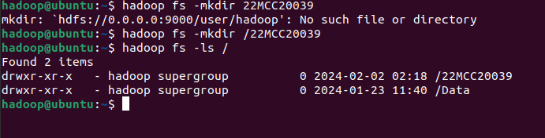

* You can check on localhost by clicking on Utilities > Browse the file system

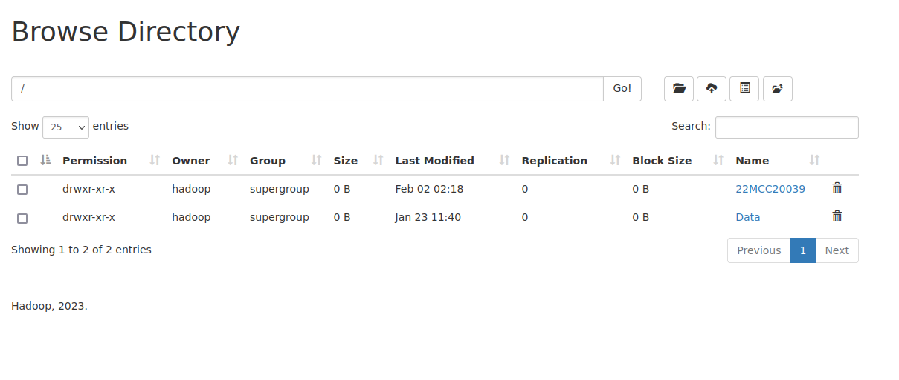

* To remove a directory, use command:

***hdfs fs -rmdir /22mcc20039***

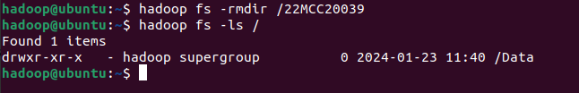

**************************************** **THE END** ***********************************************